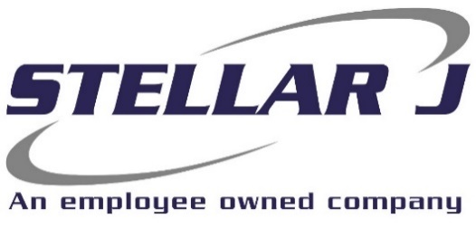

Stellar J Corporation, a General Contractor based out of Woodland, WA, is seeking an experienced Laborer to join our team for a project in Elk City, Idaho.

Qualified candidates must have at least three years

Construction Experience

Requirements:
- Ability to follow directions.
- Operate range of power tools.
- Must be physically fit and able to work at heights and in adverse weather conditions.
- Comfortable working at heights.
- Ensure all work is completed safely and in compliance with all regulations.
- Communication, teamwork and reliability required.
- Reliable transportation to and from jobsites daily.
- MUST BE IDAHO RESIDENT

Commercial carpentry experience only will NOT qualify.

Company Benefits:
- Employee assistance program
- Flexible spending account
- Sick Leave
- Family Leave
- Life Insurance
Fringe Benefits:
- Medical, Vision, Dental Insurance
- 401(K)
- Paid Time Off

Safety Sensitive Position | Federal guidelines for drug use

EOE | E-Verify Employer

If you are interested/qualified for this position, please apply at www.stellarj.com/careers or email resume to Sara at smartin@stellarj.com

