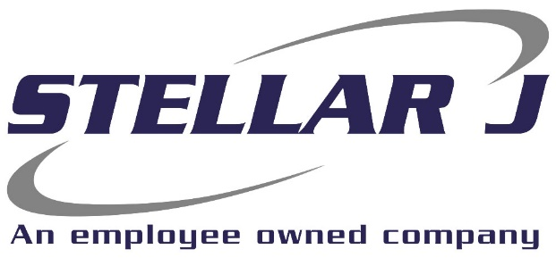

Stellar J, a West Coast based, employee-owned General Contractor, is seeking a Laboratory Technician to work on site at a project in Boardman, Oregon.

Stellar J Corporation is an employee owned company based in Woodland, Washington and operating primarily in the Pacific Northwest. Stellar J focuses on water infrastructure, including wastewater treatment facilities, clean water facilities, fish hatcheries, and bridges. If it involves moving, holding, diverting, or spanning large quantities of water or wastewater, we build it.
Ideal candidates will be self-starter, capable of working independently.
Primary Responsibilities:
- Daily Feed Stock testing on site and at 3rd party labs
- Track and record all sample results
- Other tasks to be assigned as learning as skill develops
Requirements:
- Basic computer skills
- Lab sampling experience
- Ability to manage multiple tasks, maintain accurate records and follow deadlines
- Attention to detail a must
- Must have reliable transportation to and from jobsite daily
- Dependable
EOE | Drug Free Company | E-Verify Employer

