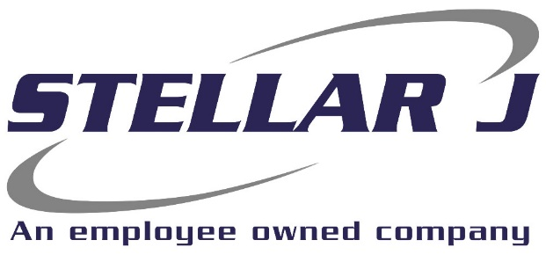

Stellar J, a West Coast based, employee owned General Contractor, is seeking a Estimating Assistant for our Corporate office in Woodland, Washington.

Stellar J Corporation is an employee owned company based in Woodland, Washington and operating primarily in the Pacific Northwest. Stellar J focuses on water infrastructure, including wastewater treatment facilities, clean water facilities, fish hatcheries, and bridges. If it involves moving, holding, diverting, or spanning large quantities of water or wastewater, we build it.
Ideal candidates will be capable of assisting the Chief Estimator and project administration team in:
Primary Responsibilities:
- Monitor bid email for all addenda and Q&A and distribute information as required
- Research bidding opportunities utilizing various platforms
- Download plans/specs/addenda for all new projects as requested by lead estimators
- Create pre bidding folders using specific naming conventions
- Add projects to living bid status spreadsheet and website in timely manner
- Phone calls to subcontractors/suppliers for bid status
- Schedule/manage bid team reviews
- Other tasks to be assigned as learning as skill develops
Requirements:
- Proficient in Microsoft word, excel and outlook
- Strong written and verbal communication
- Ability to manage multiple tasks, maintain accurate records and follow deadlines
- Attention to detail a must
- Work experience in construction office, a plus
EOE | Drug Free Company | E-Verify Employer

