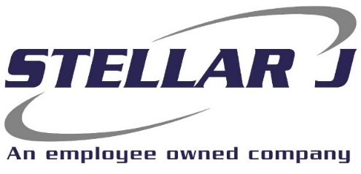

Stellar J, a West Coast based General Contractor, is seeking a Yard Laborer to join our team at the corporate office in Woodland, Washington.

Stellar J Corporation (SJC) is a merit-based, employee-owned company founded on hard work, principled business practices and the relentless pursuit of excellence. Since 1988, these core principals have allowed Stellar J to grow into a company offering General Contracting and EPC contracting services nationally. Typical projects include water treatment plants, bridges, marine terminals, and renewable energy plants that produce RNG, Hydrogen, Electricity, and other green energy processes.
Primary Responsibilities:
- Prepare, clean and paint construction equipment as directed by the Shop Manager
- Assist with servicing, repairing, cleaning, painting company-owned equipment
- Maintain cleanliness of shop, office, restrooms, and company grounds, including trash removal and restocking of office/shop restroom and company exercise room on weekly basis
- Load, unload, and transport equipment and supplies between company locations, jobsites, and suppliers
- Receive deliveries, verify accuracy, and route paperwork to the appropriate department
- Operate company vehicles safely and maintain a clean driving record
- Use company tools and equipment safely and properly
- Identify and address safety concerns, report issues, shortages, or unsafe conditions promptly
- Perform routine shop tasks (e.g., fueling equipment, sharpening blades)
- Pull and stock parts transfers from other locations as needed
- Work collaboratively and professionally with team members
- Maintain a clean, organized, and safe work environment

Minimum Skills/Experience:
- Minimum of 3 years of manual laborer experience
- Must be able to work in all weather conditions and elements
- Able to lift 50lbs, sit and stand for long periods of time
- Clean driving record
- High School Diploma

Company Benefits:
- 401(k) + matching
- Health, Vision and Dental insurance
- Employee Assistance Program
- Flexible spending account

EOE | Drug Free Company | Federal Contractor | E-Verify Employer
Hourly Wage: $22.00 per hour

Please send resume to Sara at smartin@stellarj.com or apply online at www.stellarj.com/careers

