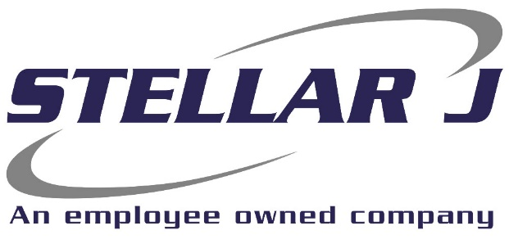
Stellar J, a West Coast based employee-owned Heavy Civil General Contractor, is seeking an Earthwork and/or Concrete Construction Estimator to join our team at our corporate headquarters.

Stellar J Corporation is an employee-owned company based in Woodland, Washington and operating primarily in the Pacific Northwest. Stellar J focuses on water infrastructure, including wastewater treatment facilities, clean water facilities, fish hatcheries, and bridges. If it involves moving, holding, diverting, or spanning large quantities of water or wastewater, we build it.
In coordination with Chief Estimator, this position will be responsible for:
- Producing detailed quantity take-offs
- Estimating Earthwork, concrete, dewatering, shoring, storm drain, sewer and waterlines for Hard Bid, Design-Build for both Public and Private Projects
- Produce accurate estimates from conceptual and schematic drawings, producing detailed, final contract estimates
- Assess site exposures/construction risks and appropriately analyze cost
- Identify and communicate constructability issues, and value-engineering alternatives
- Complete accurate take-offs from design plans and bid specifications to determine quantities and pricing for each project assigned
- Research material pricing and solicit bids from vendors and subcontractors
- Maintain bid folders
Qualifications

- 2 - 5 years’ experience in construction estimating
- Knowledge of estimating techniques, cost control and material pricing
- Ability to read shop drawings, blueprints, and specifications
- Strong construction and heavy civil knowledge
- Ability to work in fast paced environment with multiple, concurrent projects with aggressive deadlines
- Excellent communication skills and able to work as a team
- Excellent attention to detail, organizational skills, and ability to multi-task
- Proficient in Microsoft Applications, InEight Hard Dollar, HCSS Heavy Job, Bluebeam.

Company Benefits:
- 401(k) + matching
- Health, Vision and Dental insurance
- Employee assistance program
- Flexible spending account
- Paid time off
- Professional development assistance
Equal Opportunity Employer | Drug Free Company
Annual Salary: $125,000, DOE
Qualified candidates please send resume to smartin@stellarj.com

