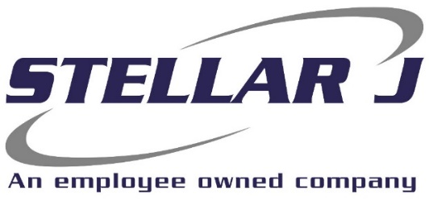
Stellar J, a West Coast based General Contractor, is seeking a Project Manager to join the Alternative Fuels Division – Specific Methanol, DME from BioGas - Process Facility Construction Project.

Stellar J Corporation (SJC) is a merit-based, employee-owned company founded on hard work, principled business practices and the relentless pursuit of excellence. Since 1988, these core principals have allowed Stellar J to grow into a company offering General Contracting and EPC contracting services nationally. Typical projects include water treatment plants, bridges, marine terminals, and renewable energy plants that produce Methanol, DME, RNG, Hydrogen, Electricity, and other green energy processes.
Primary Responsibilities:
- Prepare & plan for construction of the project
- Assist in procurement and management of subcontractors and suppliers
- Prepare and update project schedule/schedule of values/payment applications
- Manage change order process
- Establish and maintain strong relationship with owners, subcontractors, regulatory agencies, and public
- Provide project leadership for project performance, monitoring of schedule, costs, equipment, manpower, materials, safety, & quality control
- Provide leadership and technical support to project engineers, field engineers and superintendents
- Integrate with Existing Division Management Teams, and Project Management Staff in place
- Understand and enforce contractual responsibilities, contract documents, and resolve disputes
- Oversee project documentation, including shop drawings, submittals, RFIs, and logs
- Oversee site safety and ensure all workers have a safe working environment
- Possess thorough knowledge of plans and specifications
- Be effective at scheduling and multitasking
- Lead team and project meetings

Requirements:
- B.S in Construction Management/related field or equivalent work experience in a management role
- 3 years of experience leading construction projects as a Project Manager
- Travel - Project specific needs may vary, intended project location is Texas.
- 2-Year commitment to project specific location is necessary.
- Initial location at home office for onboarding/training, alternate project specific assignments will vary travel requirements.
Company Benefits:
- 401(k) + matching
- Health, Vision and Dental insurance
- Employee assistance program
- Flexible spending account
- Paid time off
- Professional development assistance
EOE | Drug Free Company | Annual Salary: $250,000
Please send resume to Sara at smartin@stellarj.com

